FurniCart- Furniture Shop E Commerce
Tagline: “Style your home, one tap away.”

Submitted by:
Hira Asghar (FA23-BSE-074)
Samiya Azeem (FA23-BSE-087)
Muhammad Uzair (FA22-BSE-036)
Muhammad Affan (FA22-BSE-024)

Submitted to:
Mam Mina

Course:
MAD Lab

Week 1:
App Identity + GITHUB Kickoff

Submission date
17-11-2025

Task A:
App Name and Tagline

App Name: FurniCart
Tagline: “Style your home, One tap away”.

FurniCart is an online Furniture shopping app that helps user browser, choose and purchase furniture easily through a user-friendly interface.

Task B:
App screens and Navigation flow
Main. Dart
Main screens:
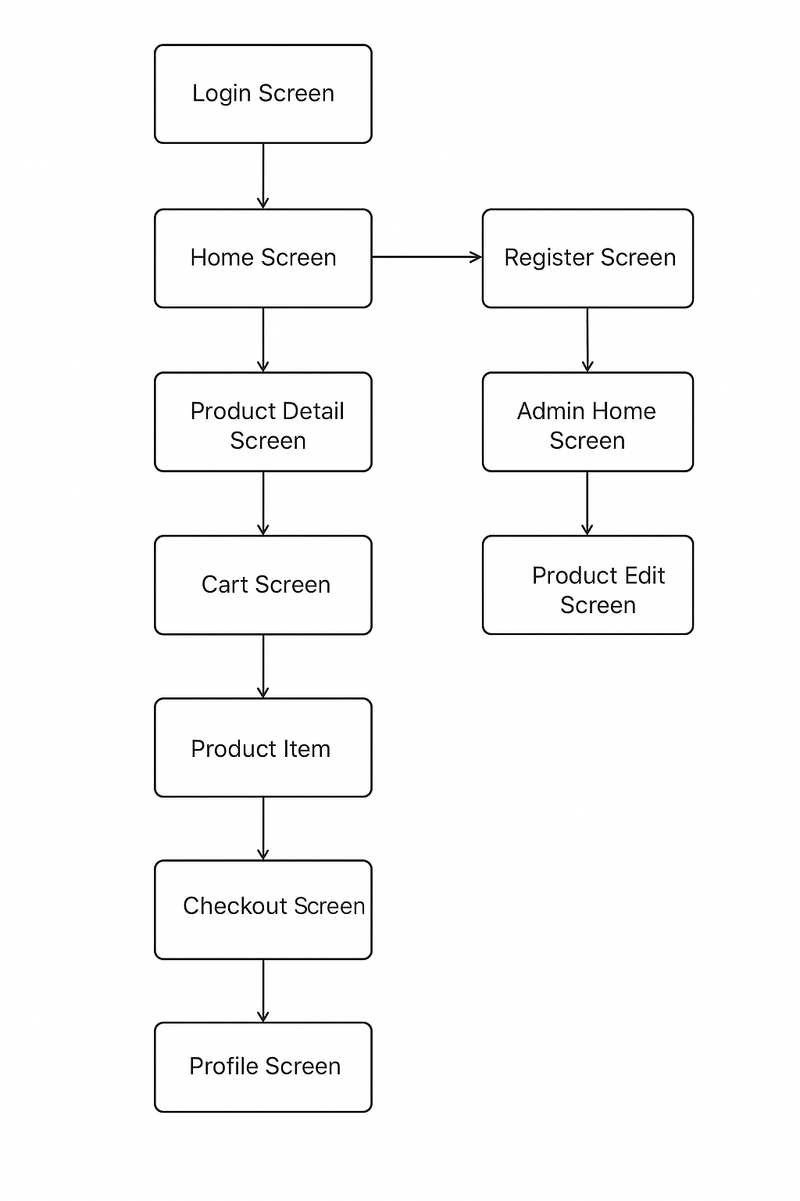
Sketch
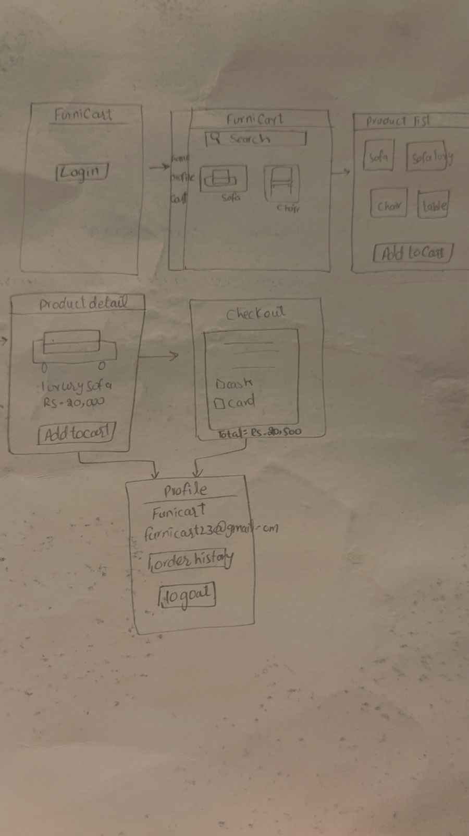
TASK C:
Home screen
Scaffold
├── AppBar
│ └── Title: "Furniture Shop"
│
├── Drawer
│ └── Custom Drawer (widgets/app_drawer.dart)
│
└── Body (Column)
├── SearchBar (widgets/search_bar.dart)
│
├── Expanded
│ └── ListView.builder
│ └── ProductItem (widgets/product.dart)
│
└── FloatingActionButton (Cart Icon)

Task D
Repository Name:
Furniture-shop-e-commerce
GitHub link
https://github.com/Hiraa846/Furniture-shop-e-commerce

